**Ideation Phase**

**Brainstorm & Idea Prioritization Template**

|  |  |
| --- | --- |
| Date | 27 June 2025 |
| Team ID | LTVIP2025TMID20380 |
| Project Title | HouseHunt: Finding Your Perfect Rental Home |
| Maximum Marks | 4 Marks |

# Brainstorm & Idea Prioritization Template

### **Project Title:** House Hunt – Finding Your Perfect Rental Home

## **Step 1: Team Gathering and Problem Statement Selection**

The team came together with a mix of frontend, backend, and design skills. We discussed real-life challenges in finding rental homes and decided to build a platform that helps people easily search for and find rental properties.

### ✅ Final Problem Statement:

“To create a web application that helps users find rental homes based on location, budget, and preferences.”

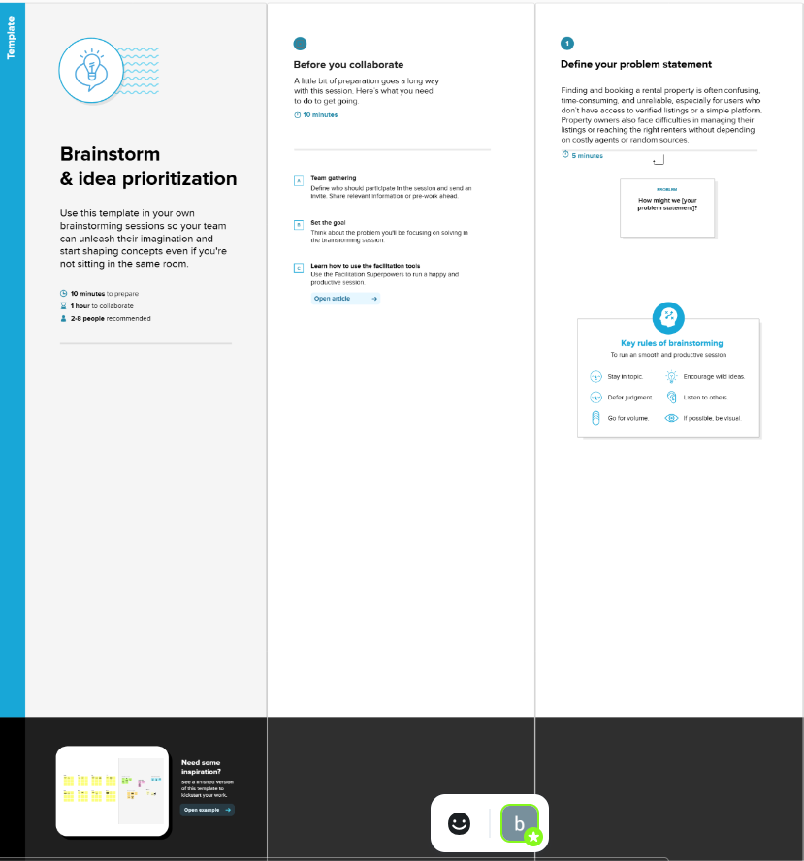

## **Step 2: Brainstorming Ideas and Grouping**

We listed as many ideas as possible—no filtering, just creative thinking. Then, we grouped the ideas into four main categories:

### 💡 Feature Ideas:

**1. Search and Filters**

* Search by city or area
* Filters for price, number of rooms, pet-friendly, etc.

**2. User Features**

* Login and register
* Contact property owner

**3. Admin Features**

* Admin login
* Add, edit, or remove property listings

**4. Future Ideas**

* Email alerts for new listings
* Virtual property tours
* Chat with landlords
* AI-based recommendations

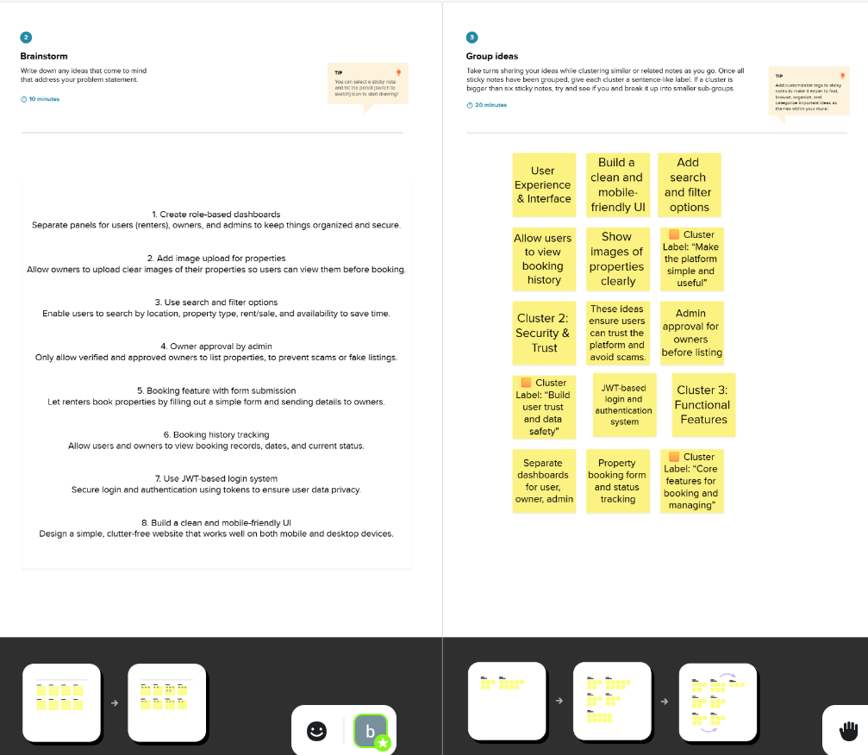

## **Step 3: Idea Prioritization**

We used simple categories: **Must Have**, **Nice to Have**, and **Future Features**.

### Must Have (for Version 1.0)

* Property search with filters
* Property details page
* User login & registration
* Admin dashboard for listings

### Nice to Have

* Contact owner button
* Responsive mobile design

### Future Features

* Email alerts for new listings
* Virtual property tours
* Chat with landlords
* AI recommendations

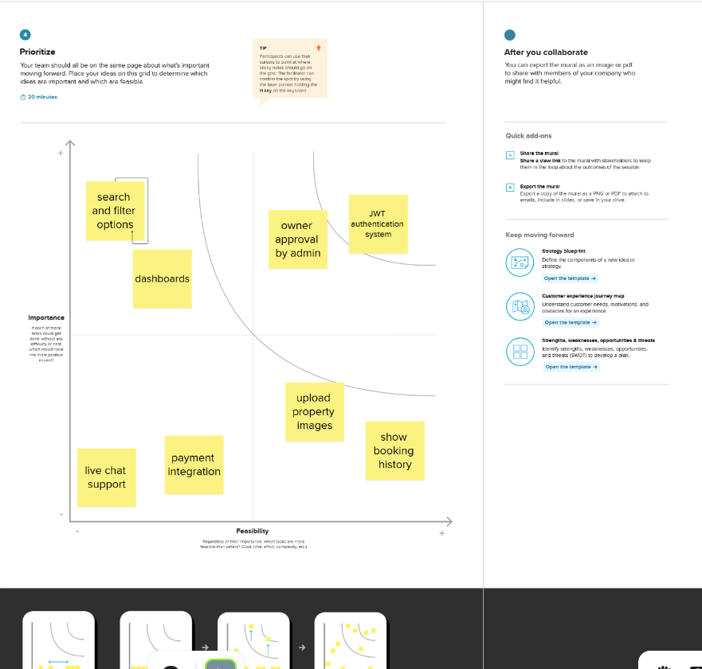

## ✅ Summary

The team used brainstorming to come up with many creative ideas. We then picked the most important features to build first. The rest will be added in later updates. This approach helps keep the project focused and achievable